Sealine Data Chat Test Plan
# | Questions | Responses
1 | How many tracking are in transit. | SQL: SELECT COUNT(*) AS InTransitCount  FROM Sealine_Tracking  WHERE [Tracking Status] <> 'Delivered';
 |  | Checkpoint: If chatUI return different query, the result should be the same as running the query above against the database directly.
2 | How many in transit tracking depart from Houston. | SQL: SELECT COUNT(*) AS InTransitCount FROM Sealine_Tracking WHERE [Tracking Status] <> 'Delivered' AND ([POL City] LIKE '%Houston%' OR [POL Country] LIKE '%Houston%' OR [POL Country Code] LIKE '%Houston%' OR [POL LOCode] LIKE '%Houston%')
 |  | Checkpoint: If chatUI return different query, the result should be the same as running the query above against the database directly.
3 | show me the route for trackings 038NY1490725, 038NY1485768 | SQL: WITH route AS (SELECT DISTINCT TrackNumber, [Pre-POL Latitude] AS Lat, [Pre-POL Longitude] AS Lng, [Pre-POL City] AS LocationName, 'PRE-POL' AS RouteType, 1 AS MinOrderId, [No Of Containers] AS NoOfContainers, 'PRE-POL:' + CONVERT(varchar, CAST([Pre-POL Date] AS DATE), 23) + CASE WHEN [Pre-POL isActual]=1 AND [Pre-POL Occurred]='Yes' THEN ' [A]' WHEN [Pre-POL isActual]=1 AND ([Pre-POL Occurred]='No' OR [Pre-POL Occurred] IS NULL) THEN ' (A)' ELSE ' (E)' END AS EventLines FROM Sealine_Tracking WHERE [Pre-POL Latitude] IS NOT NULL AND [Pre-POL Longitude] IS NOT NULL UNION ALL SELECT DISTINCT TrackNumber, [POL Latitude], [POL Longitude], [POL City], 'POL', 2, [No Of Containers], 'POL:' + CONVERT(varchar, CAST([POL Date] AS DATE), 23) + CASE WHEN [POL isActual]=1 AND [POL Occurred]='Yes' THEN ' [A]' WHEN [POL isActual]=1 AND ([POL Occurred]='No' OR [POL Occurred] IS NULL) THEN ' (A)' ELSE ' (E)' END FROM Sealine_Tracking WHERE [POL Latitude] IS NOT NULL AND [POL Longitude] IS NOT NULL UNION ALL SELECT DISTINCT TrackNumber, [POD Latitude], [POD Longitude], [POD City], 'POD', 3, [No Of Containers], 'POD:' + CONVERT(varchar, CAST([POD Date] AS DATE), 23) + CASE WHEN [POD isActual]=1 AND [POD Occurred]='Yes' THEN ' [A]' WHEN [POD isActual]=1 AND ([POD Occurred]='No' OR [POD Occurred] IS NULL) THEN ' (A)' ELSE ' (E)' END FROM Sealine_Tracking WHERE [POD Latitude] IS NOT NULL AND [POD Longitude] IS NOT NULL UNION ALL SELECT DISTINCT TrackNumber, [Post-POD Latitude], [Post-POD Longitude], [Post-POD City], 'POST-POD', 4, [No Of Containers], 'POST-POD:' + CONVERT(varchar, CAST([Post-POD Date] AS DATE), 23) + CASE WHEN [Post-POD isActual]=1 AND [Post-POD Occurred]='Yes' THEN ' [A]' WHEN [Post-POD isActual]=1 AND ([Post-POD Occurred]='No' OR [Post-POD Occurred] IS NULL) THEN ' (A)' ELSE ' (E)' END FROM Sealine_Tracking WHERE [Post-POD Latitude] IS NOT NULL AND [Post-POD Longitude] IS NOT NULL) SELECT TrackNumber, Lat, Lng, LocationName, RouteType, MinOrderId, NoOfContainers, EventLines FROM route WHERE TrackNumber IN ('038NY1490725', '038NY1485768') ORDER BY TrackNumber, MinOrderId ASC
 |  | Response: 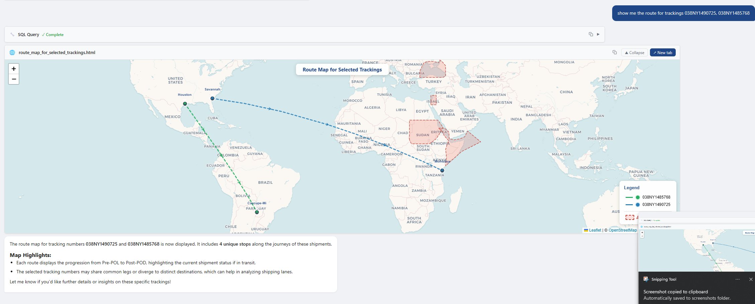
4 | show me the containers route map for tracking 038VH9479901 and 038VH9465510 | SQL: SELECT v.Container_NUMBER, v.TrackNumber, v.Lat, v.Lng, v.LocationName, v.MinOrderId, v.EventLines, v.Vessel FROM (SELECT TrackNumber + '-' + [Container Name] AS Container_NUMBER, TrackNumber, [Location Latitude] AS Lat, [Location Longitude] AS Lng, [Location Name] AS LocationName, MIN([Event Sequence ID]) AS MinOrderId, STRING_AGG([Event Description] + ':' + CONVERT(varchar, CAST([Event Date] AS DATE), 23) + CASE WHEN [Event Date isActual]=1 AND [Event Occurred]='Yes' THEN ' *A*' WHEN [Event Date isActual]=1 AND ([Event Occurred]='No' OR [Event Occurred] IS NULL) THEN ' (A)' ELSE ' (E)' END, CHAR(10)) WITHIN GROUP (ORDER BY [Event Sequence ID]) AS EventLines, MAX([Vessel Name]) AS Vessel FROM Sealine_Container_Event WHERE [Location Latitude] IS NOT NULL AND [Location Longitude] IS NOT NULL GROUP BY [Container Name], TrackNumber, [Location Latitude], [Location Longitude], [Location Name]) v WHERE v.TrackNumber IN ('038VH9479901', '038VH9465510') ORDER BY v.TrackNumber, v.Container_NUMBER, v.MinOrderId ASC
 |  | Response: 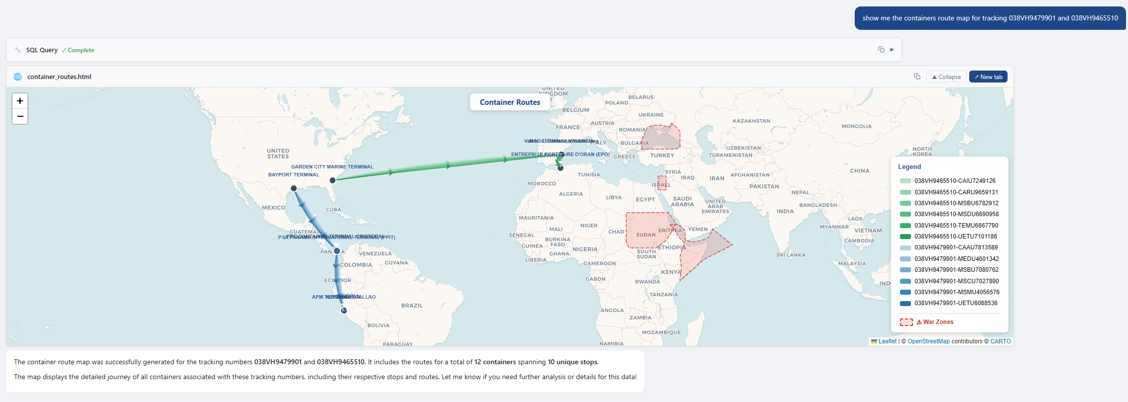
5 | list all the tracking numbers from houston to china and will arrive in next 7 days | SQL: SELECT DISTINCT TrackNumber  FROM Sealine_Tracking  WHERE [POL City] LIKE '%Houston%' AND ([POD Country] = 'China' OR [POD Country Code] = 'CN')  AND [POD Date] BETWEEN CONVERT(DATE, GETDATE()) AND DATEADD(DAY, 7, CONVERT(DATE, GETDATE()))
 |  | Checkpoint: If chatUI return different query, the result should be the same as running the query above against the database directly.
6 | show me all active tracking count by POD country in a shaded country map | SQL1: SELECT [POD Country] AS Country, COUNT(*) AS ActiveTrackingCount  FROM Sealine_Tracking  WHERE [Tracking Status] IN ('Pending Departure', 'Departed from Origin', 'Arrived Destination')  GROUP BY [POD Country]
 |  | Response: 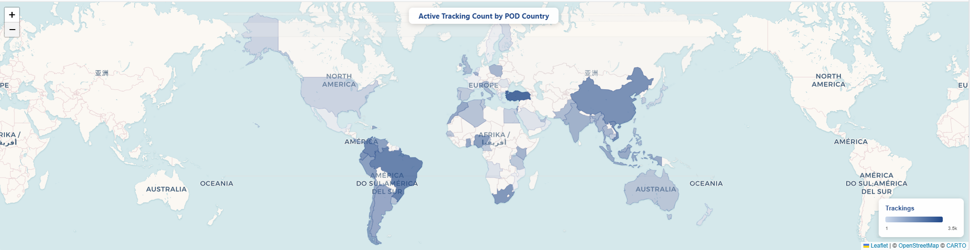
7 | show me Jawaharlal Nehru, IN (INNSA) in the map | SQL: No SQL used
 |  | Response: 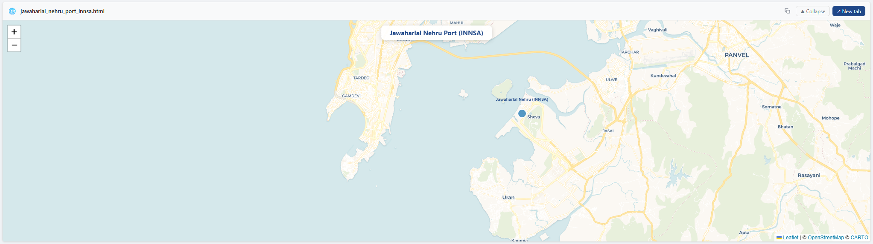
8 | show me the tracking with split-route | SQL: WITH trackings AS ( SELECT * FROM sealine_tracking WHERE [Tracking Status] = 'Departed from Origin' ), latestEvent AS ( SELECT * ,ROW_NUMBER() OVER ( PARTITION BY TrackNumber, [Container Name] ORDER BY [Event Sequence ID] DESC ) AS rn FROM sealine_container_event ), splitroutes AS ( SELECT latestEvent.TrackNumber ,trackings.[No Of Containers] ,COUNT(DISTINCT latestEvent.[Location LOCode]) AS [No Of Locations] FROM latestEvent ,trackings WHERE latestEvent.TrackNumber = trackings.TrackNumber AND latestEvent.rn = 1 GROUP BY latestEvent.TrackNumber ,trackings.[No Of Containers] HAVING COUNT(DISTINCT latestEvent.[Location LOCode]) > 1 ), uniqueLocations AS ( SELECT DISTINCT TrackNumber ,[Location LOCode] ,COUNT(DISTINCT [Container Name]) AS cnt FROM latestEvent WHERE rn = 1 GROUP BY TrackNumber ,[Location LOCode] ) SELECT splitroutes.* ,STRING_AGG( uniqueLocations.[Location LOCode] + '(' + CAST(uniqueLocations.cnt AS VARCHAR) + ')', ',' ) WITHIN GROUP (ORDER BY uniqueLocations.[Location LOCode]) AS [Split Routes] FROM splitroutes ,uniqueLocations WHERE splitroutes.TrackNumber = uniqueLocations.TrackNumber GROUP BY splitroutes.TrackNumber ,splitroutes.[No Of Containers] ,splitroutes.[No Of Locations];
Response: List of tracking number with number of transit locations will return. It should be less than 50.
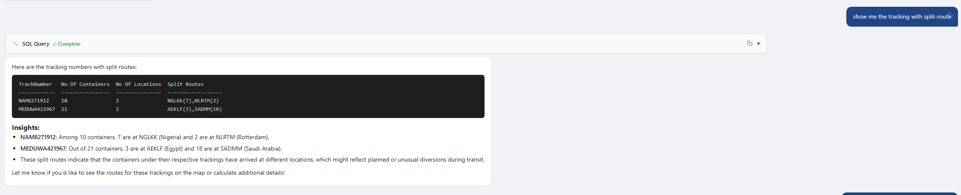
9 | list all the tracking are in transit, not delivered and the POD location is in the war zones. | SQL: SELECT  TrackNumber,  [POD City] AS POD_Location,  [POD Latitude] AS Lat,  [POD Longitude] AS Lng  FROM Sealine_Tracking  WHERE [Tracking Status] <> 'Delivered'  AND [POD Latitude] IS NOT NULL  AND [POD Longitude] IS NOT NULL  AND (  ([POD Latitude] BETWEEN 29 AND 33.5 AND [POD Longitude] BETWEEN 33.8 AND 36.5) OR  ([POD Latitude] BETWEEN 41 AND 48 AND [POD Longitude] BETWEEN 28 AND 42 ) OR  ([POD Latitude] BETWEEN 12 AND 28 AND [POD Longitude] BETWEEN 32 AND 52 ) OR  ([POD Latitude] BETWEEN 8 AND 23 AND [POD Longitude] BETWEEN 22 AND 38 )  )  ORDER BY TrackNumber
 |  | Checkpoint: If chatUI return different query, the result should be the same as running the query above against the database directly.
10 | show me number of containers in transit group the result by POD country. Show the result in a shaded map | SQL: SELECT t.[POD Country] AS Country, COUNT(DISTINCT e.[Container Name]) AS InTransitContainers FROM Sealine_Container_Event e INNER JOIN Sealine_Tracking t ON e.TrackNumber = t.TrackNumber WHERE t.[Tracking Status] <> 'Delivered' GROUP BY t.[POD Country];
Checkpoint: If chatUI return different query, the result should be the same as running the query above against the database directly.
